Diesel Jada wallet – Bleu
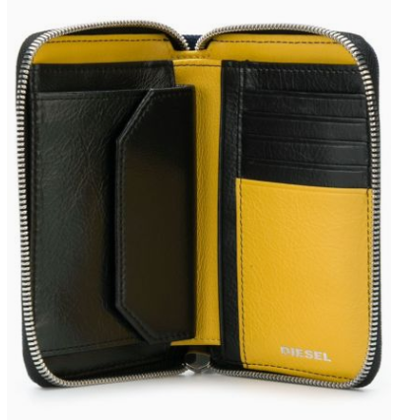

$250

Fashioned from cotton, this blue denim Jada wallet from Diesel is characterized by a shiny silver-tone star studded detail. This celestial wallet features a contrast yellow and black interior, an all-around zip fastening, a front logo plaque, a coin pocket and multiple interior card slots.

